F-Droid Companion : A Simple Guide

Before YOU Start


F-droid Official Logo

F-droid -> an installable catalogue of FOSS(Free and Open Source Software) applications for the Android platform.

F-droid (similar to Google-Playstore) is an archive where you can get thousands of apps at your finger -tips.Their apps are open-source and come with the sourcs code so the developers or even users with basic knowledge can customize them to thier liking.According to me, they don’t offer many apps as compared to Playstore, but the selection is very good and offers a wide variety of tools.

Comparison b/w Google Play-store & F-Droid.
Play-store | F-Droid
Where there are free and paid apps,but all with proprietary licenses. | Available applications have free licenses like GPL,MIT or Apache.
No source code found.There is the option of reverse-engineering.But against copyright rules. | Option of getting source code so we can reprogram ourselves.
Need Google account to even use.Create a profile and stores our information. | Another feature is that you don’t need a user account.Thus F-Droid won’t store any information related to us
Newest version can only be downloaded – A Single version. | Multiple versions of a single app can be downloaded oldest version acan be selected and can be downloaded by selecting the version.
Good Category-Fields | Categorization Problem

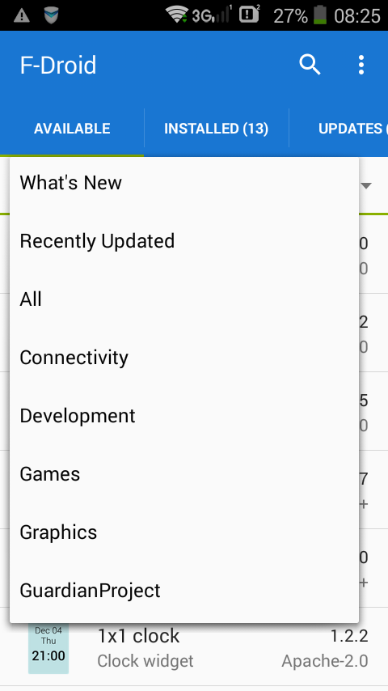

Category Selection is Less
Current Version 0.102.3

Cool Apps in F-Droid
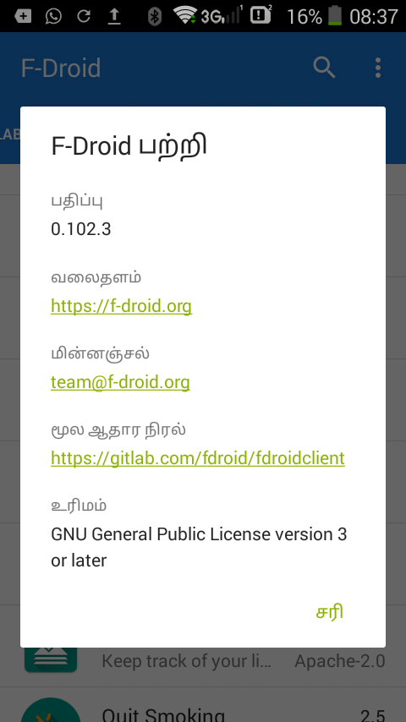
- Adaway
- Firefox
- VLC Media Player
- Shopping List
- Quit Smoking
- OpenVpn
- DuckDuckGo

Language Supported
Hindi
English
Tamil & Many..

Downoad the F-Droid Client

link:https://f-droid.org/FDroid.apk

F-Droid Forum

link:https://forum.f-droid.org/

F-Droid Latest News

link:https://f-droid.org/news/

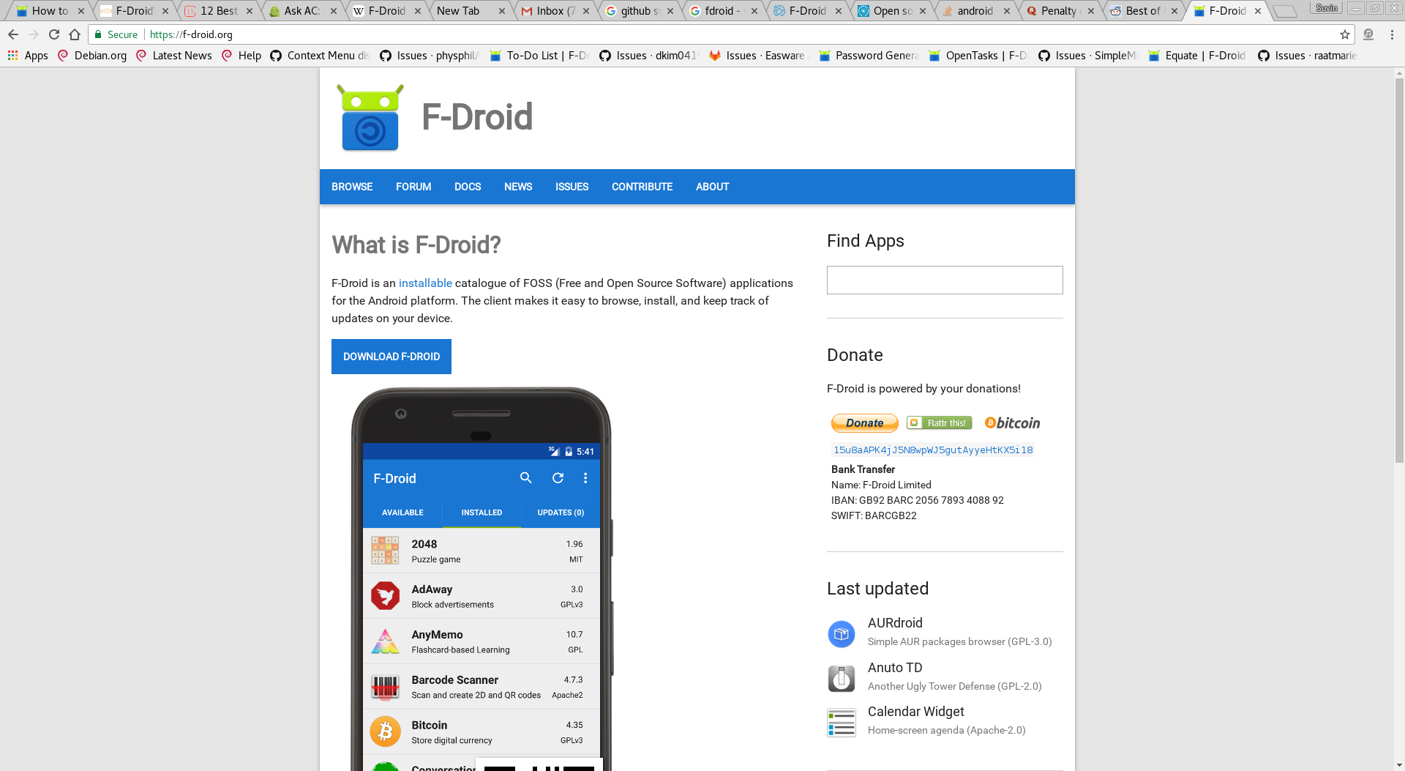

Project F-Droid

Bug Finding -An Example:

- Shopping -List:
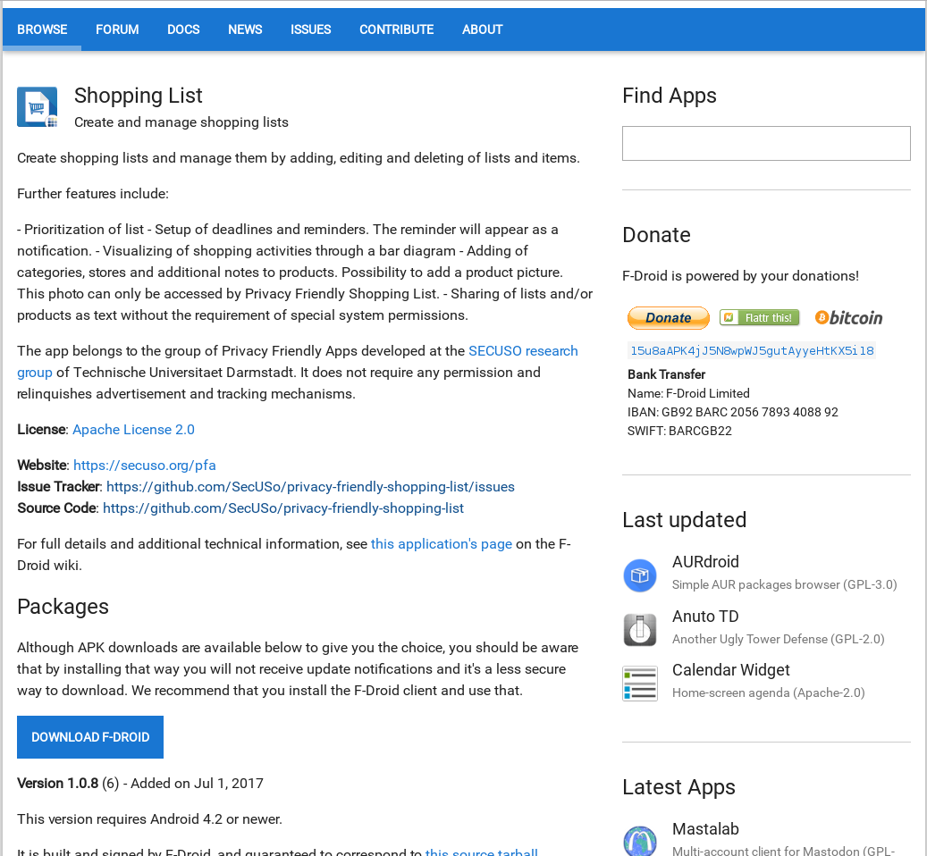

Description:
Information about the Apps.
It’s Current Version & Previous Versions.
License
Websites provided for other apps of their Contribuitions.
Issue Tracker
Source Code Link to github,gitlab or bitbucket

Issue Tracker with a# Tag.
Errors&Bugs
Enhancement in the existing Features.
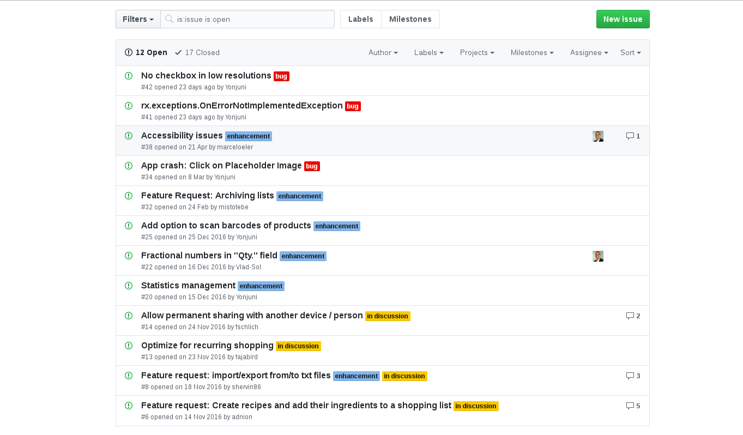
New Feature Addition.

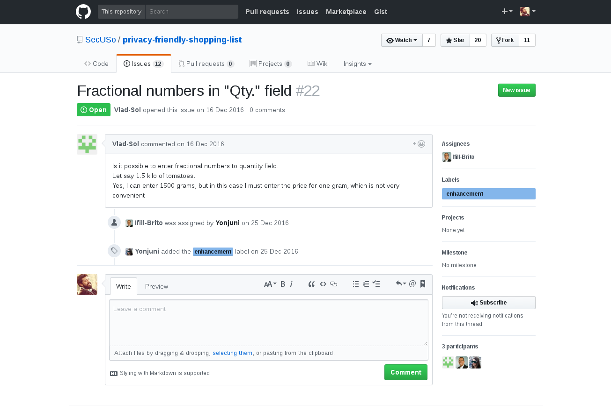
- Fractional numbers in ”Qty.” field

Error/Feature Analysis

We cannot add the quantities of other products such as weighing quantities.
Example The price of 2.5 kg rice cannot be entered as only integer quantities are allowed there.Also the unit price of 1 gram of the product should be entered to get the total price atlast.

Problem Analysed & Cleared

Source Code Download

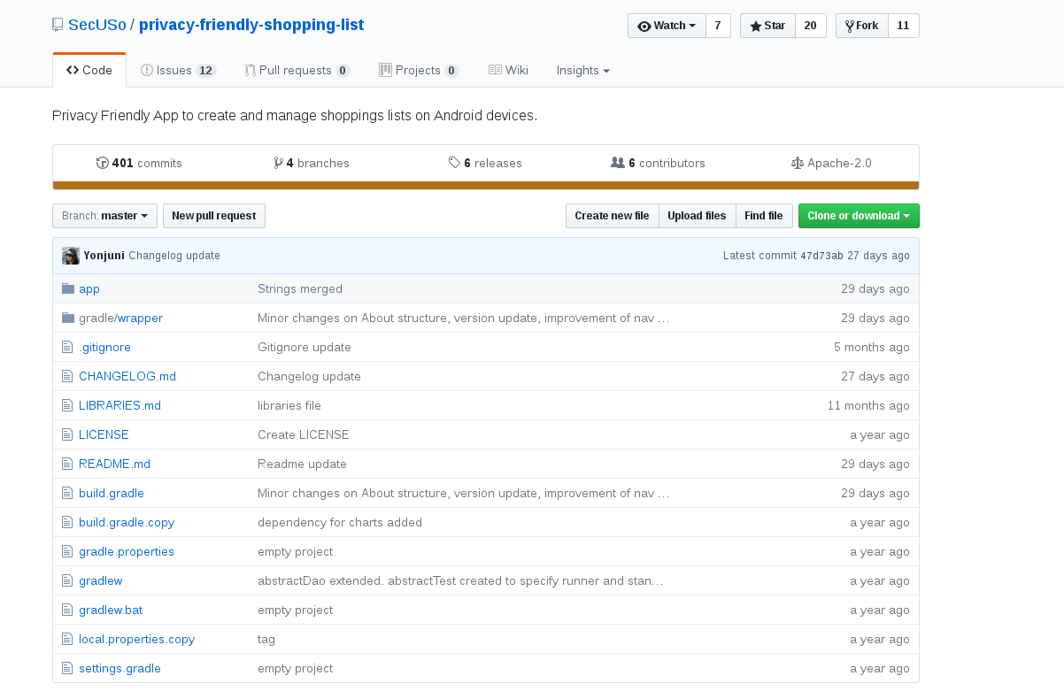
- Clone the Project into your Android Studio.

- Fork the project for further use.

- Opening the Project in Android studio.

- Working on it.(Using Android Monitor for easy finding the required Method).

- Accessibility Issues

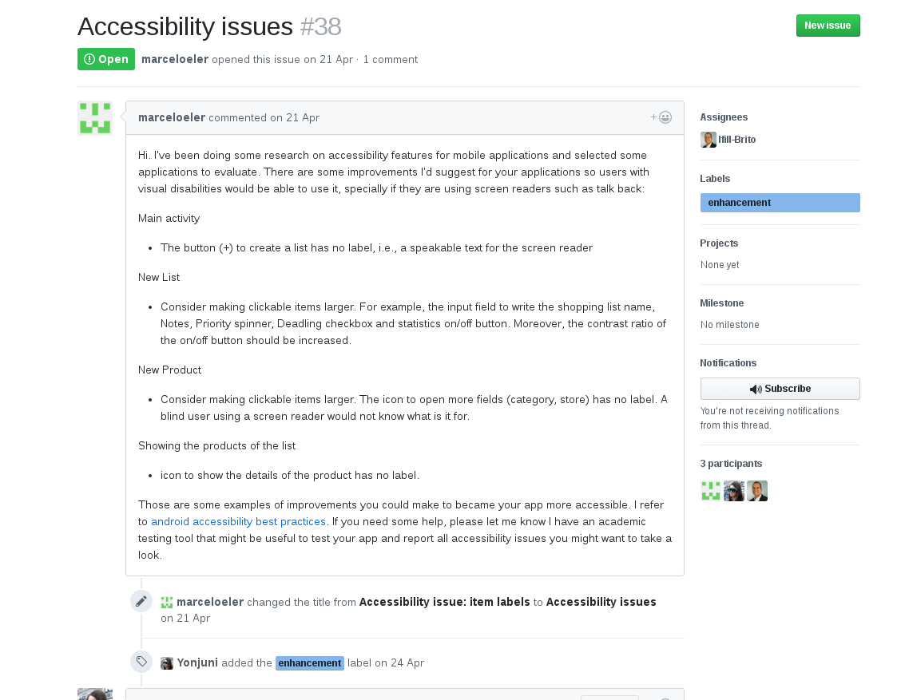

- Unable to notify the Expandable button
- Replaced with Floating Action Button and now it has been enhanced.

Updated Repository

https://github.com/suvinsnair/privacy-friendly-shopping-list.git

RESULT:
The above mentioned apps have been modified and has been updated.

ACKNOWLEDGEMENT:

We express our sincere gratitude to ICFOSS (International Centre For
Free and Open Source Software)for rendering all the facilities for the
completion of our project.

We are highly indebted to Arun Sir,our Mentor,for his
guidance and constant supervision as well as for providing necessary
information regarding the project.
We express our sincere thanks to Ms.Anjali G ,Programme Officer for
her constant support.We would like to express my gratitude towards our
parents,interns & member of(ICFOSS)for their kind co-operation and
encouragement which helped us in completion of this project.
Above all we thank Almighty God for the support ,guidance and
blessings bestowed upon us throughout our project ,which made it a
success.

